Lab 9

Question 1:-

def reverse(length,name):

if(length >= 0):

print(name[length],end="")

length -= 1

reverse(length,name)

else:

return

name = input("Enter Your Name: ")

print("The Name in reverse order will be: ",end="")

reverse(len(name)-1,name)

print()

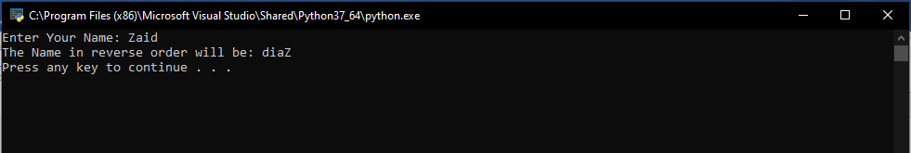

Question 2:-

length = int(input(f"Enter Number of Element: "))

array = [int(input(f"Enter Element {i + 1}: ")) for i in range (length)]

def sort(i, j, checker):

if j < length - i - 1:

if array[j] > array [j + 1]:

temp = array [j + 1]

array [j + 1] = array[j]

array[j] = temp

checker = False

sort(i,j+1,checker)

else:

return checker

for i in range(length):

checker = True

checker = sort(i,0, checker)

if checker == True:

break

print(array)

